City University
3 Maka Al-Mukarama Road
K-4 Square, Mogadishu, Somalia

Telephone Numbers:
+252-61-657-8898, +252-69-927-7440
Email: info@cu.edu.so
Website: www.cu.edu.so

City University Facilities Maintenance
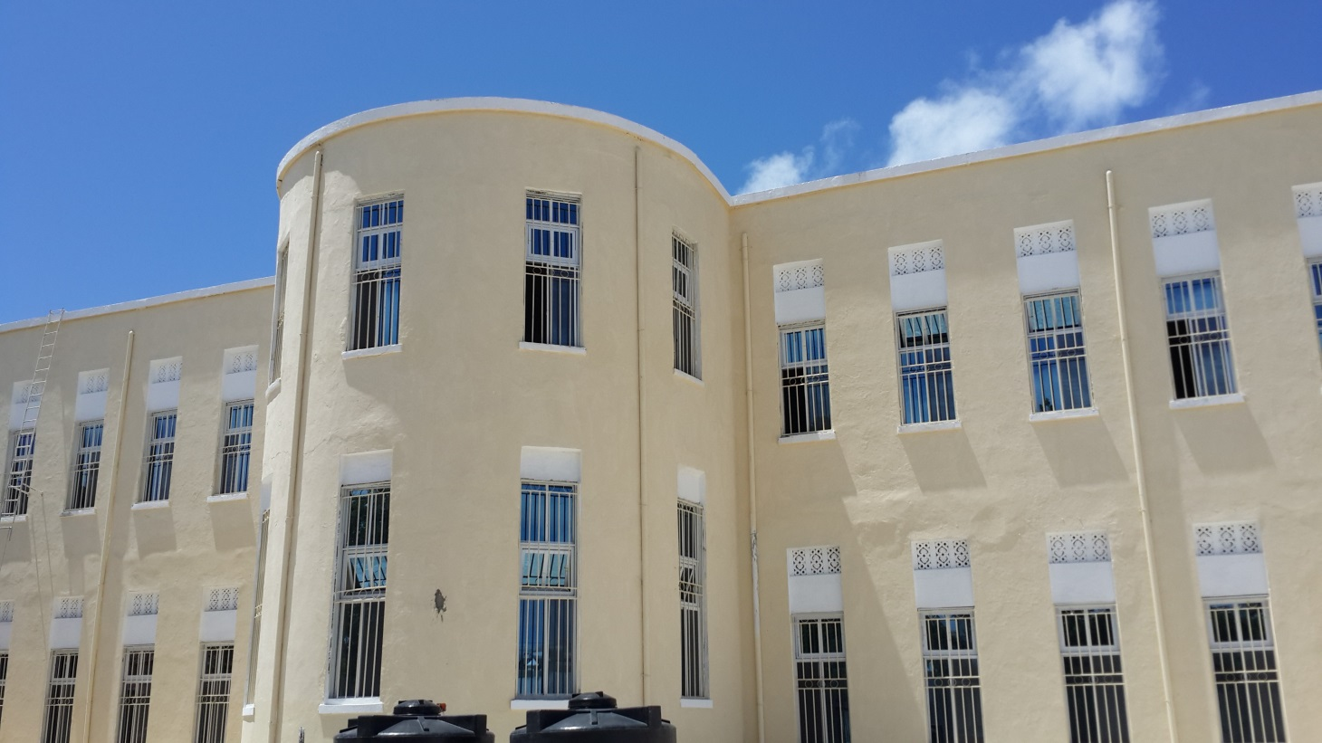
School Cleaning & Maintenance, Focus On What Matters Most
Many administrators and school facility managers tell us the school years so demanding and fast-paced that there is little time for planning the ongoing maintenance their facility needs. Thus summer can be just the right time to give more of your attention to keeping your school in good shape and addressing anything that got missed during the school year. What areas should be on every school’s cleaning and maintenance checklist?
- Classrooms
- Common Areas
- In-school Equipment Like Lockers
- Windows, Walls & Doors
- Corridors, stairs & Vestibules
- Playgrounds, Walkways & Landscaping
- Recreational Equipment
- Restrooms
- Plumbing, Fixtures & Drains
- Lighting, New Bulbs, Repairs & Cleaning
- HVAC
Work with your existing school janitorial service or use the downtime to find a better school cleaning company or outsource your school janitorial work to get up to speed and start the new school year prepared and ready to go.

